**Practise Test**

*Year 8 Physics (Energy)*

|  |  |
| --- | --- |
| **Your Name:** |  |

|  |  |
| --- | --- |
| **Score:** | / 79 |
| **Percentage:** | % |

**BEFORE YOU START:**

1. Do you have the following items?

|  |  |  |  |
| --- | --- | --- | --- |
|  | Pen |  | Highlighter |
|  | Pencil |  | Eraser |
|  | Ruler |  | Whiteout |
|  | Calculator |  | Sharpener |

You will need to bring these items to your exam.

1. What score would you like to achieve for this exam?

|  |  |
| --- | --- |
| **I would like to achieve…** | % |

1. List **three** ways you could achieve your goal.

|  |  |
| --- | --- |
| **1.** |  |
| **2.** |  |
| **3.** |  |

**MULTIPLE CHOICE (10 Marks)**

*Award one mark for each correct answer.*

|  |  |
| --- | --- |
|  | 1. Energy is measured using a unit called the: 2. A kilogram. 3. B metre. 4. C second. 5. D joule. |
|  | 1. Select which of the following require energy to happen. 2. A running in a race 3. B a leaf falling from a tree 4. C clothes drying in the sun 5. D all of the above |
|  | 1. The energy of a moving object is called: 2. A nuclear energy. 3. B gravitational potential energy. 4. C elastic potential energy. 5. D kinetic energy. |
|  | 1. Jordan watches a music video clip on his iPhone. Choose the best description of the energy transformations that are happening. 2. A electrical energy 🡪 sound energy + light energy + heat energy 3. B electrical energy 🡪 sound energy + light energy 4. C sound energy + light energy + heat energy 🡪 electrical energy 5. D sound energy + light energy 🡪 electrical energy |
|  | 1. A particular electric knife is 40% efficient. If 100 J of energy is supplied to the knife, the number of joules that is then transformed into kinetic energy is: 2. A 40 3. B 100 4. C 60 5. D 140 |
|  | 1. The number of stars found on an energy rating label indicate: 2. A the energy efficiency of an appliance. 3. B how much energy the appliance will require to operate. 4. C how much effort needs to be taken to maintain the appliance. 5. D how easy the appliance is to clean. |
|  | 1. Select which of the following contains elastic potential energy. 2. A a stretched bow about to fire an arrow 3. B a tree branch 4. C a seagull in flight 5. D an apple |
|  | 1. Select which device transforms chemical energy into kinetic energy. 2. A a torch 3. B a battery operated car 4. C a kettle 5. D an electric knife |
|  | 1. Heat flows from areas of: 2. A higher temperature to those of lower temperature. 3. B the same temperature. 4. C lower temperature to those of higher temperature. 5. D all of the above. |
|  | 1. Select the correct energy flow diagram showing energy changes that occur when operating a battery-operated fire truck that moves and sounds a siren. 2. A electrical energy 🡪 chemical energy + sound energy 3. B chemical energy 🡪 sound + heat energy 4. C electrical energy 🡪 heat + elastic potential energy 5. D chemical energy 🡪 kinetic energy + sound + heat |

**SHORT ANSWER (51 Marks)**

1. List three types of energy that are present when a match is lit. (1 mark, all or none)

1. ____________________________________

2. ____________________________________

3. ____________________________________

1. 2. A red Honda travels at 20 km/h around a curved road near the top of a mountain. A blue Honda travels at 50 km/h along a flat road near a beach.

a Statewhich car has the greatest kinetic energy. _______________________ (1 mark)

b State which car has the greatest gravitational potential energy. _______________________ (1 mark)

c Explain your answers above. (1 mark)

|  |
| --- |
|  |
|  |
|  |

1. 3. James watches a television show after school.

a State the source of energy for the television. ________________________ (1 mark)

b List any forms of energy that this energy is transformed into.

__________________________________________________________________________ (1 mark)

1. 4. Sienna turns around in a shop and her handbag knocks a vase from a stand. The vase falls and smashes on the floor.

a Recall the initial type of energy possessed by the vase. _________________________ (1 mark)

b State the name of the type of energy that this is transformed into as the vase falls.

________________________________________________________________________ (1 mark)

c Identify one other form of energy that is also transformed in this situation.  
  
________________________________________________________________________ (1 mark)

1. This diagram shows a solar cell that is used to operate a solar fan.

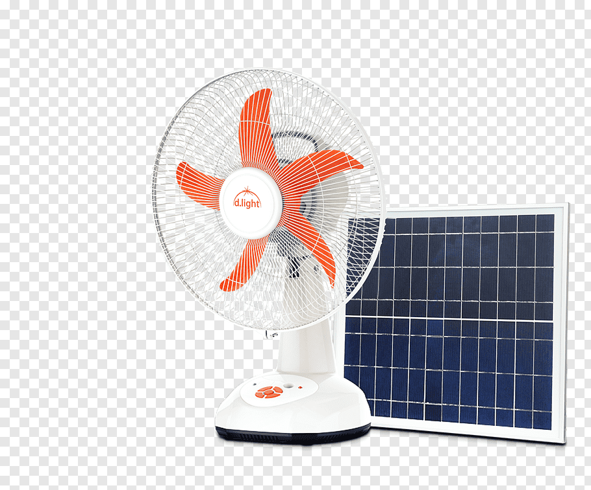

Image: <https://f1.pngfuel.com/png/542/964/950/battery-fan-solar-power-solarpowered-fan-solar-lamp-dlight-design-inc-solar-panels-offthegrid-png-clip-art.png>

1. Draw an energy flow diagram to show the energy changes that take place in this process. (3 marks)

|  |
| --- |
|  |

6. Construct an energy flow diagram showing the energy changes that occur when using a microwave oven if your energy supply is wind powered.

FLOW DIAGRAM:

_______________________________________________________________________________________ (3 marks)

7. An electric drill is a tool used by builders.

**a**  List one useful form of energy that is produced when you use an electric drill.  
  
________________________________________________________________________ (1 mark)

b Identify two other forms of energy that are produced that are not useful.  
  
________________________________________________________________________ (1 mark)

8. Many science fiction movies come to a climax with a big space battle in which there are many loud explosions. This an example of artistic licence as there can be no loud explosions in space. Explain why.

|  |
| --- |
|  |
|  |

(2 marks)

1. 9. The efficiency of an appliance is the ratio of:
2. Efficiency = $\frac{\text{useful }\text{output }\text{energy}}{\text{total input energy}}$ x 100
3. Calculate the efficiency of a food processor (used to blend food), if electrical energy is 10kJ, mechanical energy is 2kJ, sound energy is 3kJ and heat energy is 5kJ.  
      
   **SHOW ALL WORKING** and **INCLUDE UNITS**
4. (3 marks)

|  |
| --- |
|  |
|  |

1. 10. If the efficiency of the Spinners washing machine is 40%, Sparkles washing machine is 35% and the Sprinkles washing machine is 52%. List the machines from most to least efficient.
2. _______________________________________________________________________________ (1 mark)
3. 11. The table below lists the specific thermal capabilities of a number of materials. This unit is the number of joules of energy that is needed to raise the temperature of 1 kg of this substance by 1° Celsius.

|  |  |
| --- | --- |
| 1. Substance | 1. Specific thermal capacity (J kg-1°C-1) |
| 1. water | 1. 4180 |
| 1. oil | 1. 2800 |
| 1. glass | 1. 840 |
| 1. copper | 1. 385 |

1. If each material listed in the table was heated with 100 kJ of energy, the material that would be the hottest after heating is: (1 mark)

A – water B – oil C – glass D – copper

1. 12. The table below lists the typical amount of energy required per minute by a 58 kg woman and a 70 kg man to perform several activities.

|  |  |  |
| --- | --- | --- |
| 1. Activity | 1. Average energy required per minute by a 58 kg woman | 1. Average energy required per minute by a 70 kg man |
| 1. Sleeping or resting | 1. 4 | 1. 5 |
| 1. Working on a computer | 1. 8 | 1. 10 |
| 1. Light work: shop keeping, gardening | 1. 12 | 1. 16 |
| 1. Social sports such as cycling, playing tennis or cricket | 1. 16 | 1. 20 |
| 1. Heavy work: chopping wood, running, competitive sports | 1. 24 | 1. 30 |
| 1. Intense exercise such as hard physical work | 1. 40+ | 1. 50+ |

1. Lisa weighs 58 kg. In one particular hour, she uses up 720 kJ of energy. Select the activity that she was most likely to be involved in.
2. _______________________________________________________________________________ (1 mark)

13. Sound travels at approximately 340 m/s and light at 300 000 000 m/s. When a lightning bolt flashes you see the light virtually instantaneously but you don’t hear the thunder for several seconds because sound is so much slower than light. If you hear the thunder 10 seconds after seeing the lightning flash then the distance between you and the storm is approximately:

1. **SHOW ALL WORKING** and **INCLUDE UNITS**
2. (3 marks)

**14.** The following questions relate to this table: 

|  |  |
| --- | --- |
| **Planet** | **Acceleration due to gravity or g (m/s2)** |
| Mercury | 3.6 |
| Venus | 8.9 |
| Earth | 9.8 |
| Mars | 3.7 |
| Jupiter | 18.5 |
| Saturn | 11.2 |
| Uranus | 10.5 |
| Neptune | 13.3 |

Use the following formula to answer the questions that follow:  

**Weight = mass x gravity or W = mg**

a) If Jack has a mass of 60 kg then what is his weight on **Mars**?                  (2 marks)

|  |
| --- |
|  |
|  |
|  |

1. If Johnny has a mass of 62 kg and a weight of 651 Newtons on **Uranus**, then what is the value for acceleration due to gravity on **Uranus**?             (2 marks)

|  |
| --- |
|  |
|  |
|  |

1. If Zap the monkey has a mass of **40 kg** before departing the Earth’s surface, and he travels in a spaceship from the Earth to the Moon, how does his mass change when he lands on the moon?  **Justify your answer**.

(3 marks)

|  |
| --- |
|  |
|  |
|  |

15. Energy comes in many forms in the universe and we use it every day in many different ways.

a. State the law of conservation of energy?                  (1 mark)

|  |
| --- |
|  |
|  |

1. Complete the following energy flow diagram to show how a battery powered torch transforms energy.  
     
      (Ap, 4 marks)

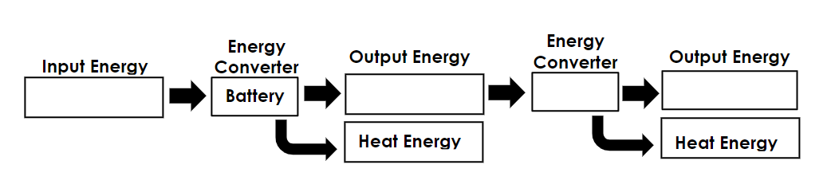

16. Jamie is at the top of a ski run which is elevated 40 vertical metres above the ground. Her mass (including her equipment) is 60kg.

**SHOW ALL WORKING** and **INCLUDE UNITS**

**Ep = mgh** (gravitational potential energy = mass x gravitational field strength x height)

**g = 9.8m/s2**(gravitational field strength)

a) Calculate her gravitational potential energy at the top of the slope. (2 marks)

|  |
| --- |
|  |
|  |
|  |

b) At the bottom of the slope he travelled 350m in 16.7seconds. What was his speed? (2 marks)

|  |
| --- |
|  |
|  |
|  |

17. Skate half pipes are a good example of how gravitational potential energy can be converted into kinetic energy.

1. Use the image of the labelled skate ramp to fill in the following table.

(2 marks)

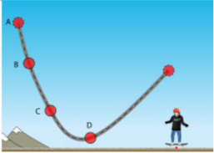

Image: <https://bcphysics180.files.wordpress.com/2017/02/skateplickers.png?w=840>

|  |  |
| --- | --- |
| **Property** | **A, B, C or D** |
| The point where there is the maximum potential energy |  |
| The point where there is the maximum kinetic energy |  |
| The point where there is the potential energy and kinetic energy are the same |  |
| The point where the skater is travelling the fastest |  |

1. Not all the potential energy from the skater was converted to kinetic energy. Name two other forms of energy that the potential energy was converted into.

             (2 marks)

_______________________      __________________________

1. Use your knowledge of the law of conservation of energy and energy conversions to explain why the skate boarder will eventually stop at the bottom of the ramp.                  (2 marks)

|  |
| --- |
|  |
|  |
|  |
|  |

1. Suggest two ways that you can increase the amount of kinetic energy converted from the gravitational potential energy and make the skater go faster.  (2 marks)

|  |
| --- |
|  |
|  |
|  |
|  |

**SCIENCE INQUIRY SKILLS (18 Marks)**

The intensity of a sound from a speaker (measured in **W/m2**) is measured at various distances from the speaker. Multiple tests were conducted at each distance and recorded in the table below.

|  |  |  |  |  |
| --- | --- | --- | --- | --- |
| **Distance** | **Sound Intensity (W/m2)** | | | |
| **Test 1** | **Test 2** | **Test 3** | **Average** |
| 2m | 0.8 | 0.9 | 0.6 | 0.77 |
| 5m | 0.3 | 0.3 | 0.3 |  |
| 8m | 0.1 | 0.08 | 0.12 |  |
| 10m | 0.08 | 0.07 | 0.05 |  |
| 11m | 0.07 | 0.06 | 0.05 |  |
| 14m | 0.05 | 0.04 | 0.05 |  |

18. Calculate the averages for each test. Go to two decimal places. (2 marks)

19. State the variables. (4 marks)

|  |  |
| --- | --- |
| **Independent** |  |
| **Dependent** |  |
| **1st Controlled Variable** |  |
| **2nd Controlled Variable** |  |

20. Write a hypothesis for the experiment. (1 mark)

|  |
| --- |
|  |
|  |
|  |

21. Plot the distance vs sound intensity on the graph below. Remember to only plot the average. Insert a line of best fit.

(8 marks)



22. Predict the sound intensity at 4m. Show your working on the graph paper. (2 marks)

|  |
| --- |
|  |
|  |

23. Write a conclusion for the experiment. (1 mark)

|  |
| --- |
|  |
|  |